# Bank Statement Reconciliations

1. User login page for new user login

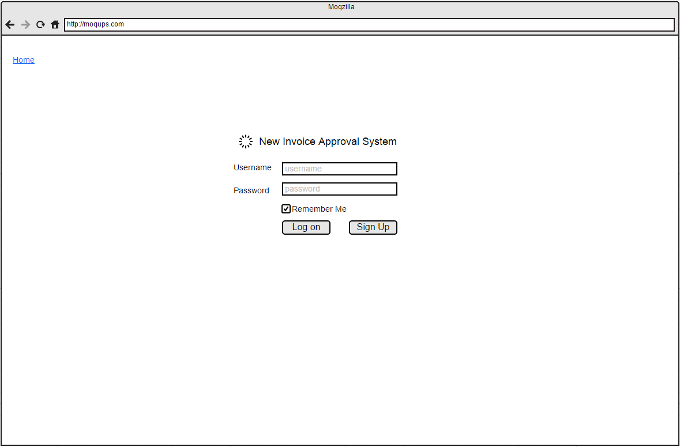

1. Selected company overview page for last 30 days activities

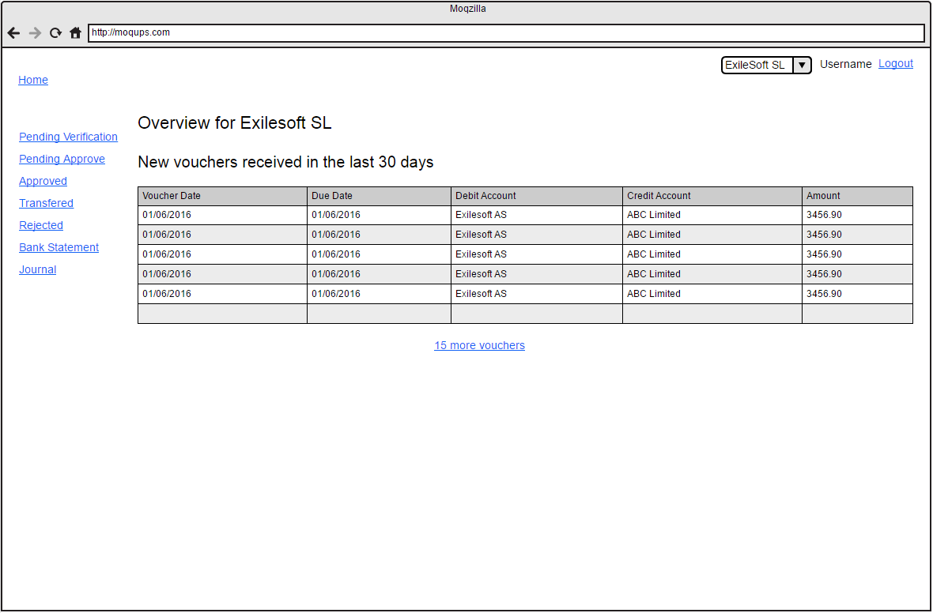

1. Bank Statement List page load upon click on bank statement link on left side

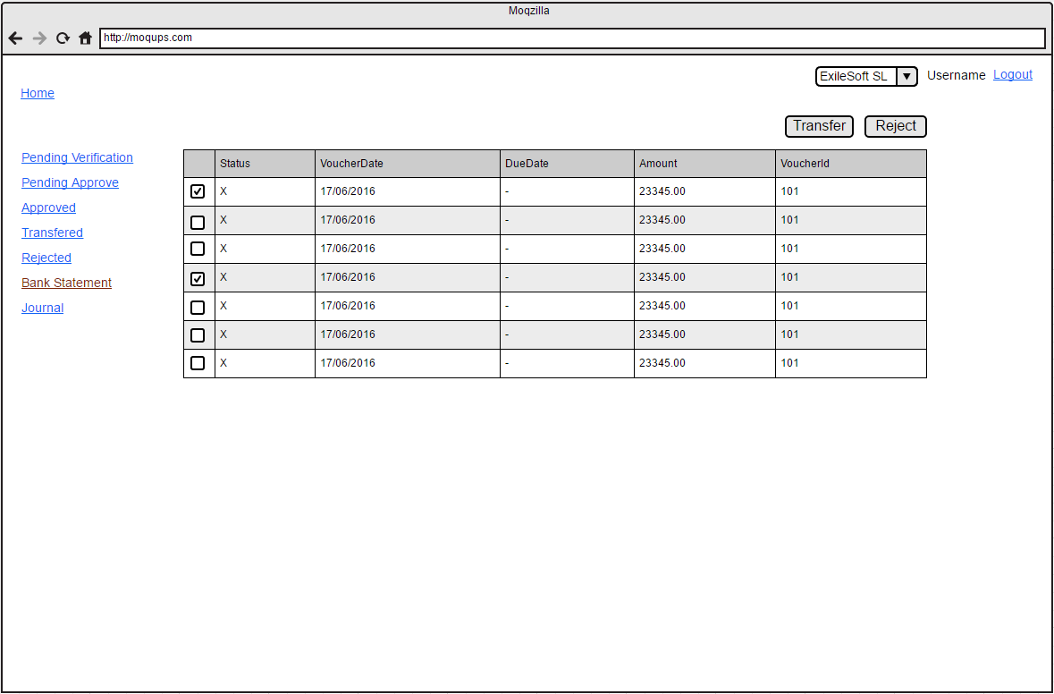

1. User will proceed selected bank statement from the list for reconcile

(Note: Out of five unsettle invoice 3 invoice was paid as confirm in the bank statement. Rest of 2 invoice will be reconcile in future bank statement)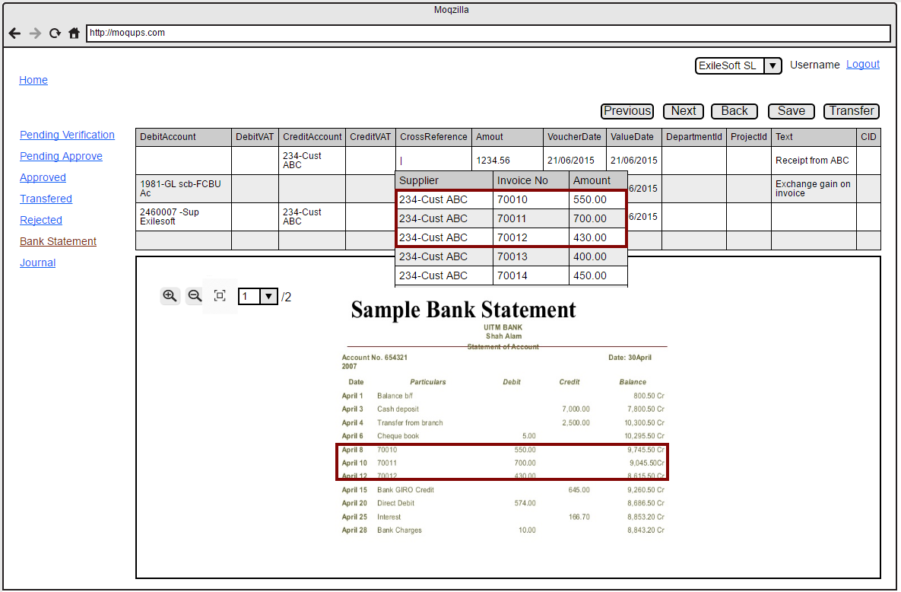

1. Bank Statement Reconcile screen….

(Note: once all the three invoice reconcile it will be appear as below)

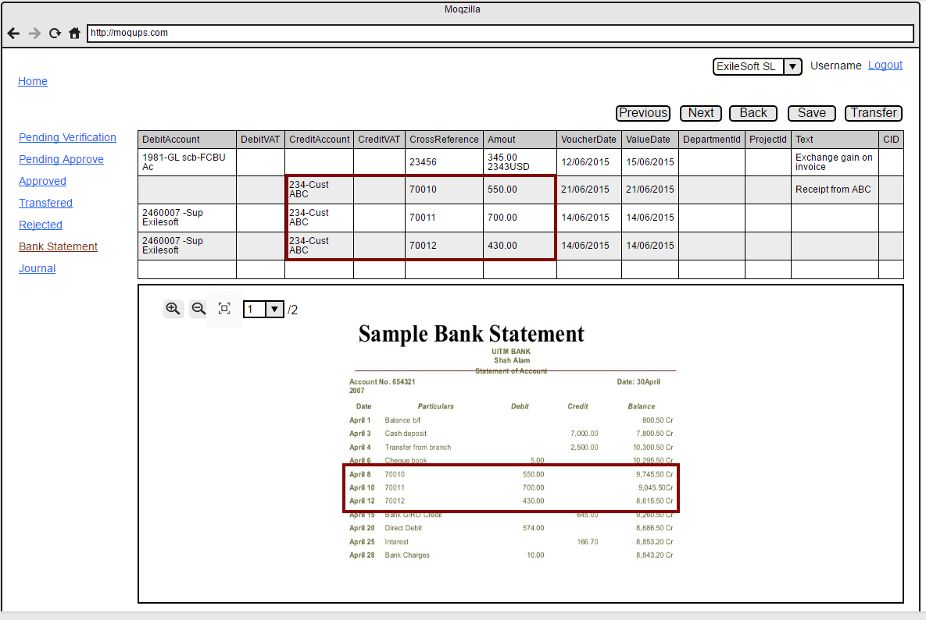

# Journal Entries

1. Journal Entry List page load once click on journal link on left side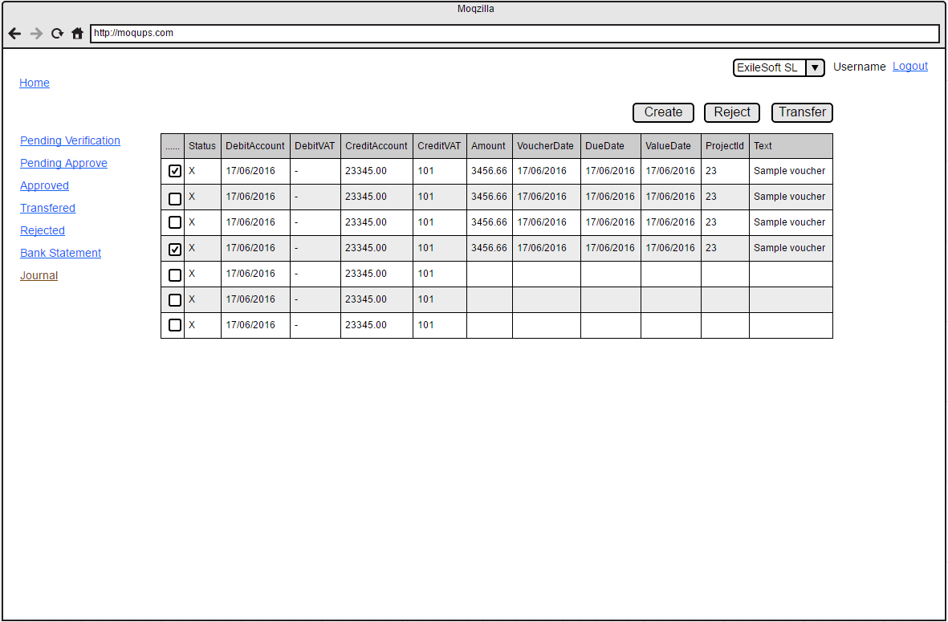
2. New Journal Create page will be load once click on Create button on list page

